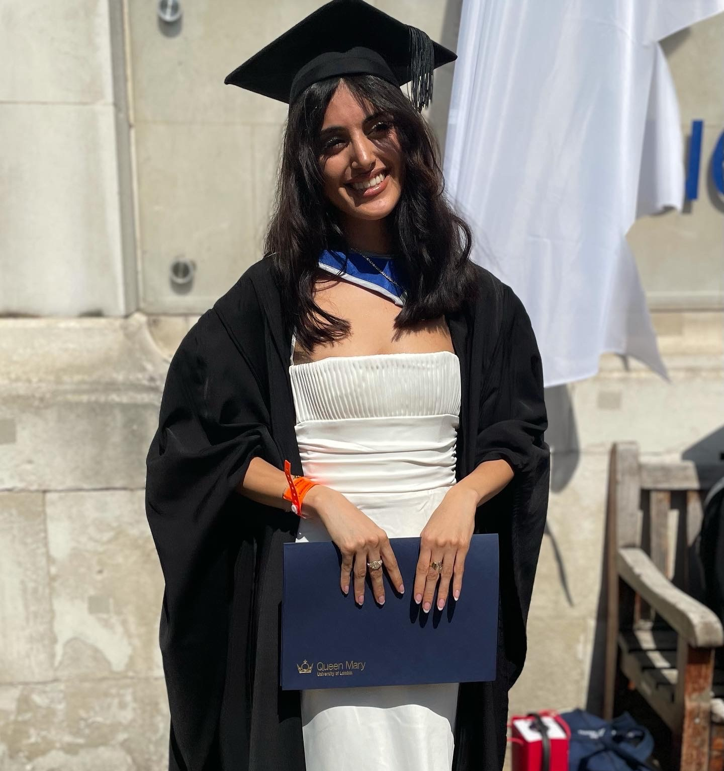 |  | Lilljan Lava daoud
Kontakt  PHONE:  (+44)07464340965  WEBBPLATS:  https://www.linkedin.com/in/lilljandaoud/  E-MAIL:  Lilljanlava@hotmail.com  competence  - I speak Arabic, Swedish, English, Spanish and Kurdish.  - With my bachelor’s degree, I cultivated my analytical and problem-solving skills.  - Coordinating a Swedish class for +30 students under the ByteLanguage project at TikTok.  - I am used to working in a fast-paced environment that has allowed me to adapt quickly to new situations and take initiative.  - As the social media committee member for the Kurdish society at my institution, I learned how to best reach out to audiences through social media channels.  - Microsoft excel proficiency |  | Education  BA International Relations with honours. Queen Mary University of London  2018–2022  Graduated with a 2:1 with an honour degree in international relations from a Russel group university.  experiences  Tiktok Community Content Management. ByteDance  2021-06-28  In my work, I am focused on creating a safer platform, specialising on the Swedish market. This includes analysing potential high risk content on the platform. As well as working a lot cross-culturally due to the global nature of the company in a fast-paced environment.  Avado FastFutures Internship  2021-01-15  The twelve-week programme was a dynamic experience with Avado where I got develop within essential areas of bussinesses, Data, Marketing, Finance alongside companies like Shell, BT and Barclays. Was an important programme to develop my interest In working with data.  European Youth Parliament UK  2021-03  Member of the non-profit organisation which provides great support for young members to expand professional networks in Europe.  Delegate, International Model United Nations Association (IMUNA)  2021-03-01  Attended the 47th IMUN online conference as a representative of Grenada in the Global Goal 2030: zero violence against children question.  Introducing to community organising. Citizens UK  2019  An introductory course to grass-root movements and helpful guide on how to expand networks within communities. Also, a member of CitizensUK Women100 programme, aimed for female leaders.  Volunteer Refugees Welcome Stockholm  2017  I offered my help to the Refugees Welcome organisation in  Stockholm where my knowledge in Arabic and Kurdish proved extremely helpful. Where we welcomed refugees mid the European refuge crises.

